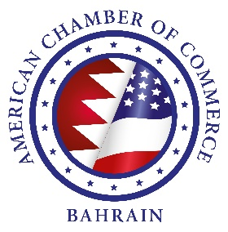

Annual General Meeting & Dinner
Tuesday, 24 September 2019
6:00 – 8:30pm
Wyndham Grand Bahrain Bay – Ballroom

PROGRAM

6:00-6:30pm Doors open – registration & networking

6:30-7:30pm AGM business meeting & Board election

7:30-8:30pm Dinner & election results announced

AGM AGENDA
- Quorum

- Approve Minutes from 2018 AGM

- President’s Report – Review achievements of past year Sep 2018 to Sep 2019

- Approve 2018 Audited Financial Statement

- Guest Speaker: HE Justin Siberell, US Ambassador to Bahrain

- A Look Ahead – Open discussion on the Coming Year’s Priorities, Initiatives & Delivering Value to Members

- Thank departing BoD members

- Board of Directors Election for 2019-2021 term

- Any other business

- Adjourn AGM

- 7:30pm Dinner & Election Results Announcement

Proxy Letter – if you are unable to attend please fill out the proxy letter and send back to us so we may have the needed quorum.

